Hooli XYZ

**Sprint 4 Report**

**Sprint Period:** 02/05/2016 – 17/05/2016

**Members:**

Connor Beardsmore – 15504319

Brendan Lally – 18407220

Adam Brown – 18338993

Jordan Chou – 18348691

Edward Lim - 18339145

**Table of Contents:**

1. Sprint Planning
2. SCRUM Meetings
3. Sprint Review
4. Sprint Retrospective

Appendix A: CSV of all user stories

Appendix B: Screenshots of Functionality

**1. Sprint Planning**

**User Stories:**

The following user stories were selected for completion in Sprint 4.

|  |  |  |  |
| --- | --- | --- | --- |
| Number: | User Story: | Area: | Effort Points: |
| 1 | As an Admin, I want an Admin Tag so that other Users can see my account as an Admin. | Admin | 1 |
| 2 | As a User, I want to add images to my submission so that I can add relevant images to my submission. | Posting Submission | 3 |
| 3 | As a User, I want to add videos to my submission so that I can add relevant videos to my submission. | Posting Submission | 3 |
| 4 | As a User, I want to only vote once for a submission, so that voting is fair and equal for all users. | Voting | 8 |
| 5 | As a User, I want to un-vote on submissions so that I can change my mind on voting. | Voting | 5 |
| 6 | As a User, I want to up-vote on improvements so that I can support improvements I like. | Voting | 3 |
| 7 | As a User, I want to down-vote on improvements so that I can acknowledge improvements I dislike. | Voting | 3 |
| 8 | As a User, I want other users to see my level when I post so that I can show off my level when posting. | Rewards | 3 |
| 9 | As a User, I want to gain levels based on points so that I am rewarded for utilizing the platform. | Rewards | 5 |
| 10 | As a User, I want to gain points when my submission receives votes so that I am rewarded for good work. | Rewards | 1 |
| 11 | As a User, I want gain points for posting submissions so that I am encouraged to post again. | Rewards | 1 |
| 12 | As a User, I want gain points for posting improvements so that I am encouraged to post again. | Rewards | 1 |
| 13 | As a User, I want to gain points for voting on submissions so that I am encouraged to vote again. | Rewards | 1 |
| 14 | Final Release | Final Release | 1 |

**Sprint Goal:**

The overall goal of the Sprint 4 was to meet the final release and finish all remaining user stories. We aim to finish implementing the voting system, and both start and finish the entire rewards system. The addition of both images and videos to submissions also needs to be completed. By the end of Sprint 4, we aim to have a fully implemented and polished final product to release to the product owner.

**Task Breakdown:**

The user stories for the sprint were broken down into simpler high-level task units. These tasks must be finished before the user stories can be reviewed, accepted and completed:

* Git good.
* sdsd
* sds
* sd
* sds
* ds
* dsd
* sd
* sd
* sd

**Task Distribution:**

|  |  |
| --- | --- |
| Members: | Area of Focus: |
| Connor, Jordan | Voting System |
| Jordan, Adam | Rewards System |
| Brendan, Edward | Posting Submission (Images/Videos). Admin Tag. |

**Effort Estimation:**

Once the initial voting and rewards systems have been fully implemented, the majority of related user stories are relatively simple tasks. Thus, stories (4) and (5) are fairly time-consumptive while all other stories take substantially less effort. As most of the user stories are easily implemented, we hope to also put moderate effort into cleaning up the UI and enhancing the overall feel of the platform.

**2. SCRUM Meeting**

**Meeting #1: 02/05/16**

|  |  |  |  |
| --- | --- | --- | --- |
| Members: | Completed | Uncompleted | Issues |
| Connor, Jordan | - | (4) (5) (6) (7) | - |
| Jordan, Adam | - | (8) (9) (10) (11) (12) (13) | May spread workload over other groups, depending how work progresses this week. |
| Brendan, Edward | - | (1) (2) (3) | - |

**Meeting #2: 9/05/16**

|  |  |  |  |
| --- | --- | --- | --- |
| Members: | Completed | Uncompleted | Issues |
| Connor, Jordan | (6) (7) (4) | (5) | Will require some additional modifications to the backend model storing the votes |
| Jordan, Adam | (8) (9) (10) (11) (12) (13) | - | - |
| Brendan, Edward | (1) | (2) (3) | Implemented functionality, only UI modifications required |

**Meeting #3: 16/05/16**

|  |  |  |  |
| --- | --- | --- | --- |
| Members: | Completed | Uncompleted | Issues |
| Connor, Jordan | (4) (5) (6) (7) | - | - |
| Jordan, Adam | (8) (9) (10) (11) (12) (13) | - | - |
| Brendan, Edward | (1) (2) (3) | - | - |

**Early Finish:**

Talk about how we finished early so we again just cleaned code and worked on UI

**3. Sprint Review**

**Completed User Stories:**

* As an Admin, I want an Admin Tag so that other Users can see my account as an Admin.
* As a User, I want gain points for posting submissions so that I am encouraged to post again.
* As a User, I want gain points for posting improvements so that I am encouraged to post again.
* As a User, I want to up-vote on improvements so that I can support improvements I like.
* As a User, I want to down-vote on improvements so that I can acknowledge improvements I dislike.
* As a User, I want to add images to my submission so that I can add relevant images to my submission.
* As a User, I want to add videos to my submission so that I can add relevant videos to my submission.
* As a User, I want to only vote once for a submission, so that voting is fair and equal for all users.
* As a User, I want other users to see my level when I post so that I can show off my level when posting.
* As a User, I want to gain levels based on points so that I am rewarded for utilizing the platform.
* As a User, I want to gain points when my submission receives votes so that I am rewarded for good work.
* As a User, I want to gain points for voting on submissions so that I am encouraged to vote again.
* Final Release

**Unfinished User Stories:**

* As a User, I want to un-vote on submissions so that I can change my mind on voting.

**Review Data:**

* Total Stories: 46
* Completed: 45
* Uncompleted: 1
* Total Progress: 98%

**Review Data:**

The statistics and data within the figures below were produced via the Pivotal Tracker software utilized by the team. They illustrate the progress throughout the current iteration and progress towards the final release.

**4. Sprint Retrospective**

**Sprint Ratings**

* Communication: 8/10
* Performance: 9/10
* Work Ethic: 8/10

**What went well?**

Sprint 3 retrospective wanted same productivity levels, finishing early, keeping a defect log + documenting code extensively before its complete.

**We want to keep doing:**

While this is the final sprint on this project, the team wants to work on the following aspects in future projects.

**What did not go well?**

Asdsdsdadsadaas

Asdadsasad

**We want to start:**

B;ahasfhsdhdsdsd

asddsada

**Appendix B: Screenshots of Functionality**

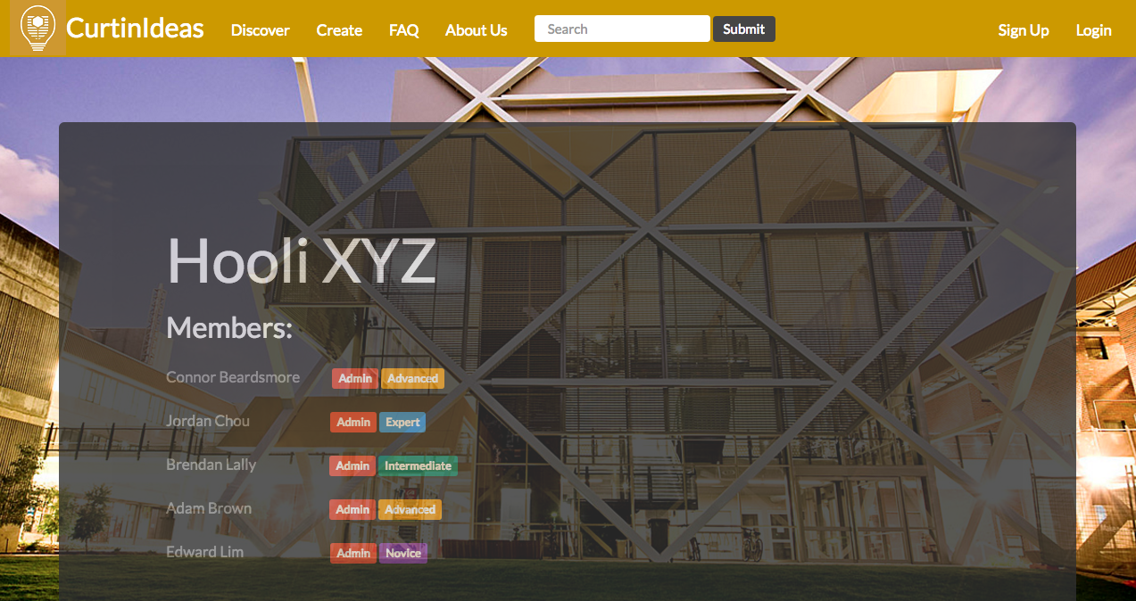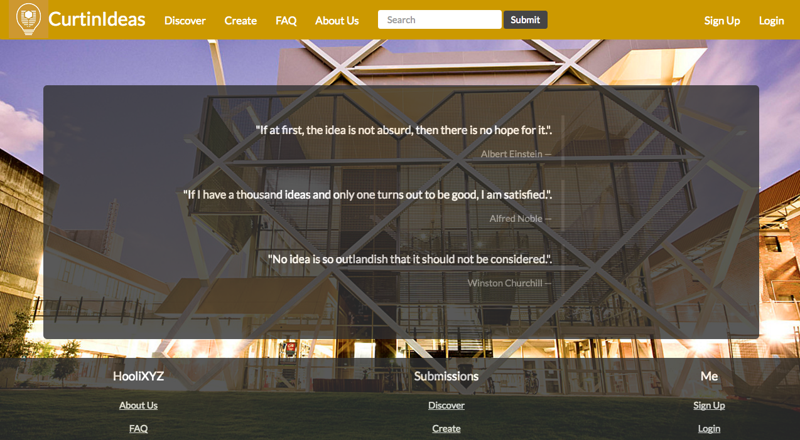

Figure 6: Home Page

Figure 7: About Us

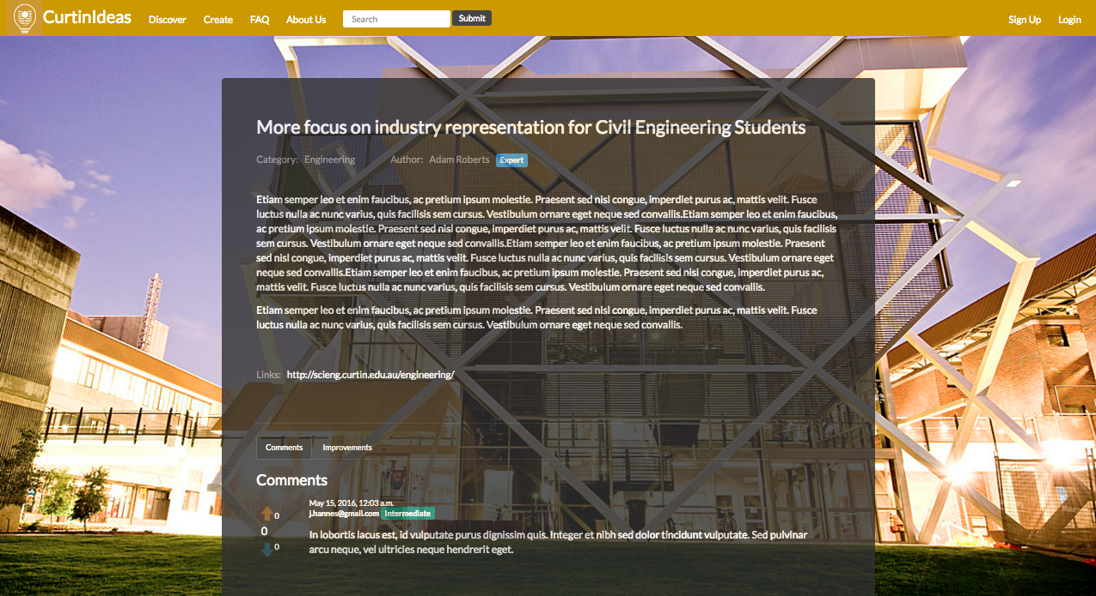

Figure 8: Discover Page

Figure 9: Submission View

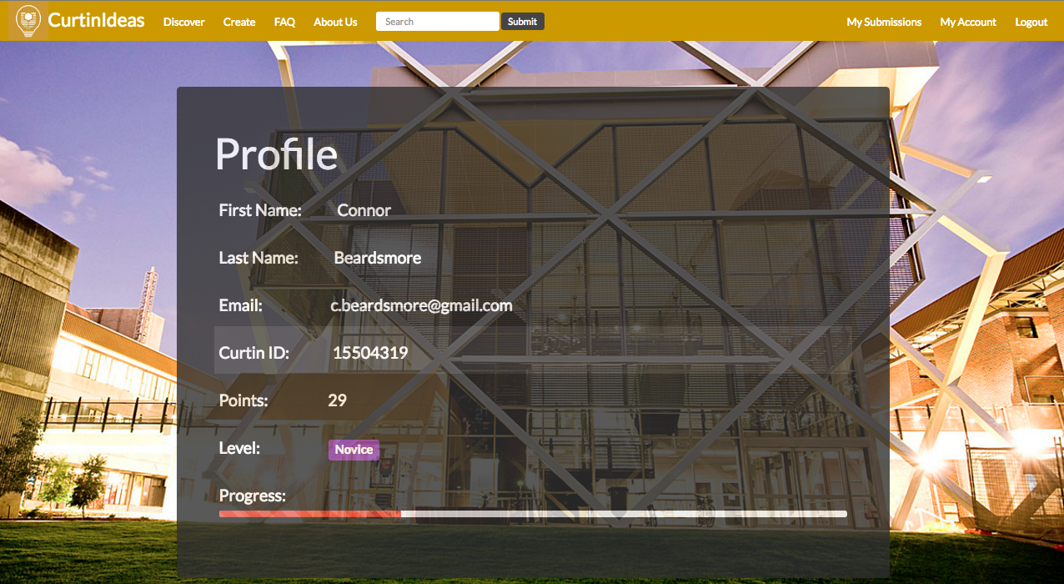

Figure 10: User Profile